**EXPERIMENT NO 11**

**PROCEDURES**

**Aim:**

* Create a table with attributes students and marks.
* Insert values into the table.
* Create a procedure to get the merit students (marks > 50).
* Create a procedure to get marks of a given id (using in).
* Create a procedure to display highest marks (using out).
* Create a procedure to get marks of a given id (using in and out).

**Components:**

Procedures: Database Procedures (sometimes referred to as Stored Procedures or Procs) are subroutines that can contain one or more SQL statements that perform a specific task. They can be used for data validation, access control, or to reduce network traffic between clients and the DBMS servers.

**CODE**

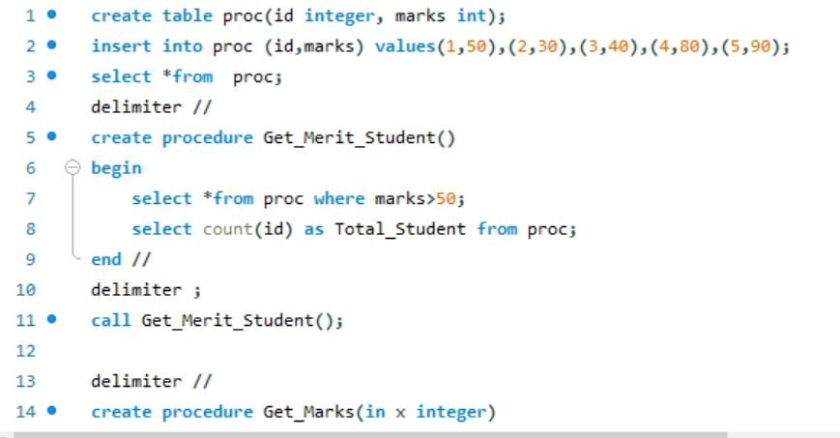

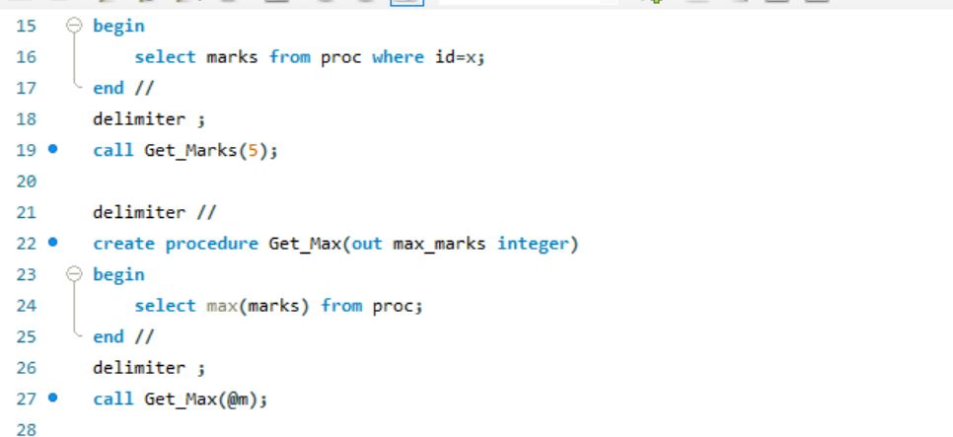

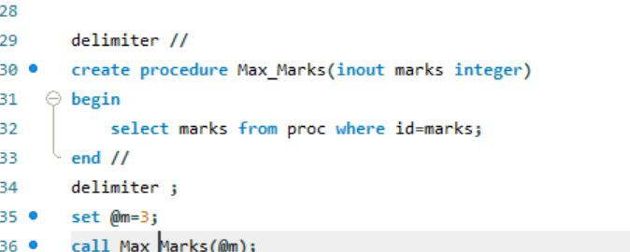

**OUTPUT**

